A class diagram is a type of diagram which is part of a unified modeling language (UML) that defines and gives the overview and structure of the system in terms of classes, methods, attributes, and the relationship amongst the different classes.

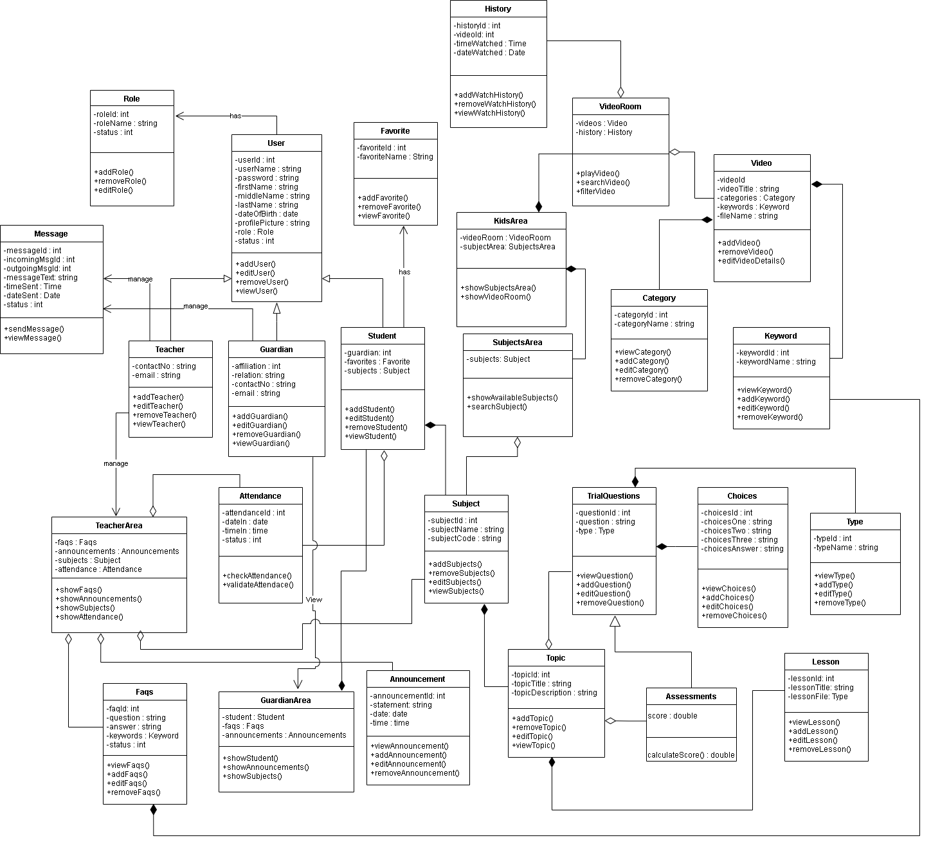

**Figure 1. Class Diagram**

Figure 1 shows all the classes that will be used on the Web-based Computer-Aided Instruction for Nursery Students and their corresponding methods and the relationships and the attributes of each class in the diagram. The diagram consists of class for Role, User, Teacher, FAQs, Attendance, Parent, Student, GuardianArea, TeachersArea, Announcement, Subject, Subjects Area, Subject Grade, KidsArea, Video, VideoRoom, Category, Keywords, TrialQuestion, Topic, Assessments, and Choices.

The parents, student, and teacher inherit the User table’s instances or properties which provide the needs for users, such as username, password, first name, middle name, last name, sex, date of birth, profile, picture, role, and status of an account. The parent has property affiliation, email, and contact number. The teacher has properties of email and contact number. While the student contains the section and their parent.

The kid’s area class has a video room and subject area. The video room class has videos and a history class. The subject area class has subjects. The video class contains a property video title, category, keywords, and file name. The history class contains a property of video, time watched and date watched. The subject class is composed of topics and has a property of subject name and subject code. While the topic class contains a topic title and topic description. The assessment class has score property and inherits all properties of the trial question class that are composed of choices and has a property of question.

The teacher manages the teacher’s area class which contains subjects, announcements, FAQs, and attendance of the student. The parent has an access to view the parent’s area class that contains the student information, faqs, announcements. They both manage the message class to contact each other if they have questions. It depicts the system's overall presentation, as well as the various objects included in the proposed system, as well as their relationships and how objects interact with one another.

Use case diagrams are a visual representation of a system's requirements, including internal and external factors. The roles of the actors are portrayed across these diagrams. The purpose of this diagram is to provide an overview of the actors and their roles, functionalities, as well as dependencies presented in the diagram.

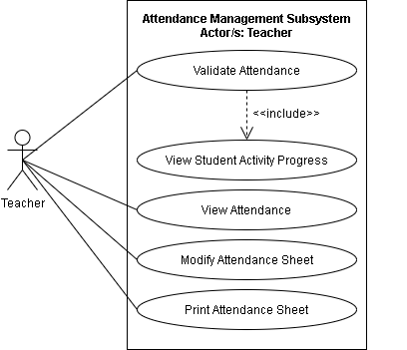

**Figure 2. Use Case Diagram for Attendance Management Subsystem**

Figure 2 shows the Use case diagram for the Attendance Management Subsystem. The illustration shows the capabilities of the teacher. The teacher can validate attendance which includes the view of student’s activity progress, student’s attendance, modify attendance sheet, and print attendance sheet.

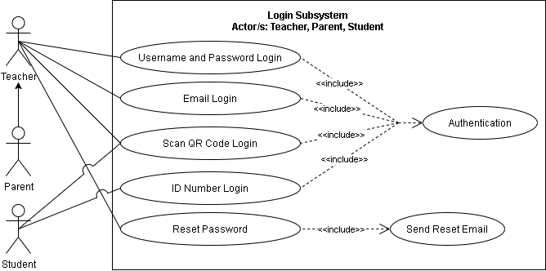

**Figure 3. A Use Case Diagram for Login Subsystem**

Figure 3 shows the Use case diagram for the Login Subsystem. The illustration shows the capabilities of teachers, parents, and students. The teacher and parents have access to username, password, e-mail, QR code, and reset password which is the primary authentication of the system. Otherwise, the student can only access the system by scanning the QR code and by its unique ID number.

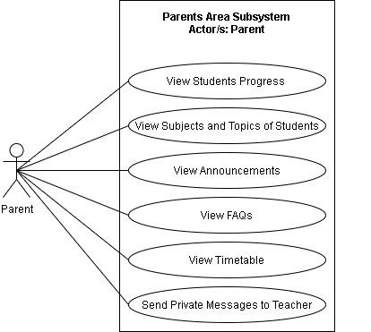

**Figure 4. Use Case Diagram for Parents Area Subsystem**

Figure 4 shows the Use case diagram for the Parents Area Subsystem. The illustration shows the capabilities of parents. The parents have access to view student’s progress, view student’s subjects and topics, view announcements, view FAQs, view Timetable, and send a private message to the teacher.

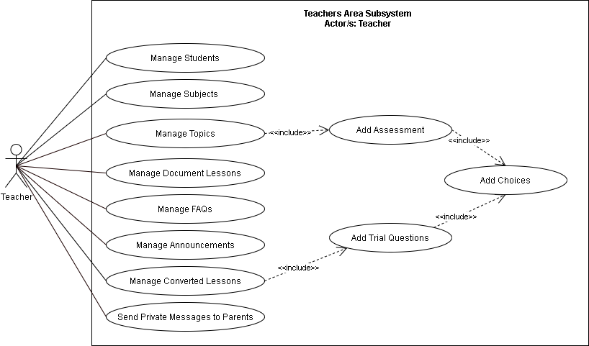

**Figure 5. Use Case Diagram for Teachers Area Subsystem**

Figure 5 shows the Use case diagram for the Teachers Area Subsystem. The illustration shows the capabilities of teachers. The teachers have access to Manage of Subjects, Manage topics which include adding of assessment and adding of choices, Manage Document Lesson, Manage FAQs, Manage Announcements, Manage Converted Lessons which includes adding of trial questions and adding of choices, and send a private message to parents.

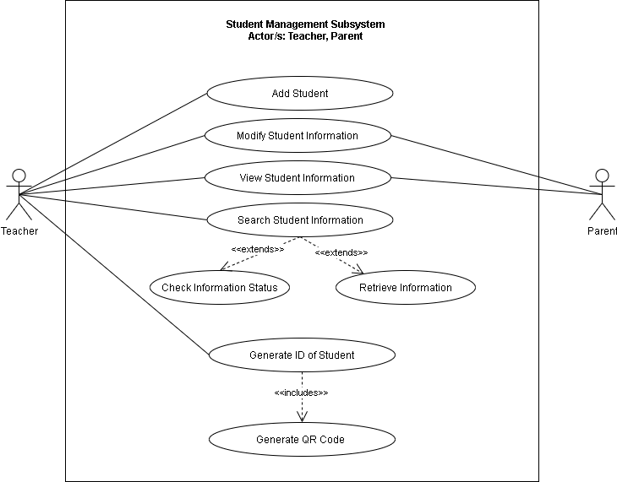

**Figure 6. Use Case Diagram for Student Management Subsystem**

Figure 6 shows the Use case diagram for the Student Management Subsystem. The illustration shows the capabilities of teachers and parents. The teachers have access to add students, modify student information, view student information, search student information, and generate id of students which includes generating QR codes. Otherwise, the parent has access to modify student information, view student information.

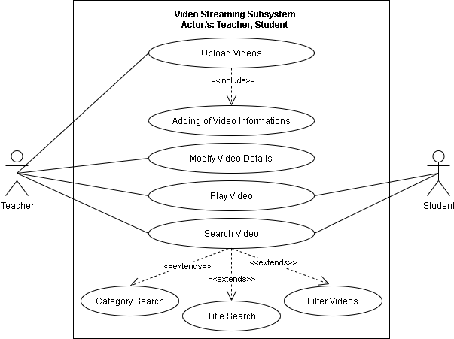

**Figure 7. Use Case Diagram for Video Streaming Subsystem**

Figure 7 shows the Use case diagram for the Video Streaming Subsystem. The illustration shows the capabilities of teacher and student. The teachers can upload videos that include adding required information, modify video details, search videos, and play videos. Otherwise, the student can only search for video and play videos.